HIBISCUS FLOWERS
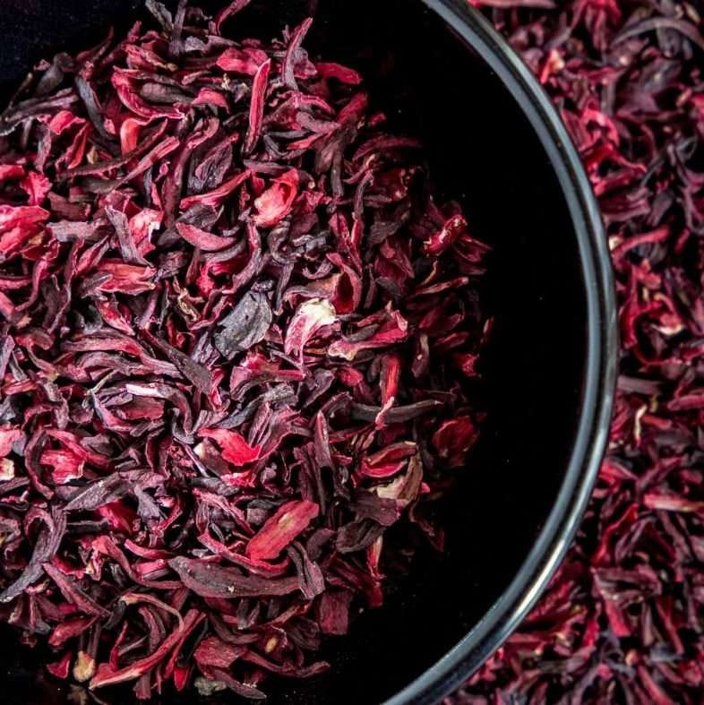
Zobo as locally known in Nigeria, commonly known as Hibiscus Flower is highly valued for its vibrant color and tart flavor, with majority uses it in teas, medicinal products, animal fodder, and more. Internationally, dried hibiscus flowers are processed into herbal beverages, jellies, and confectioneries, due to its global demand and making it one of our major exports. Harvested from October through December, our hibiscus flower undergoes perfect processing and cleaning, packaging, and storage processes to ensure no or less contamination and uphold our commitment to high quality. We maintain stock availability throughout the year to meet ongoing demand.

We sourced from smallholder farmers in Nigeria’s North East, our hibiscus flower supports both environmental stewardship and fair farmer welfare. Our regular shipments reach key markets, including UAE, Mexico, Germany, the United States, the United Kingdom, China, El Salvador, Guatemala, and various parts of Europe. We also supply local beverages companies. Specifications of hibiscus flower Color: Dark Red, bright red, Purple Moisture content: 5% Max Min: 90% Whole Flowers Foreign Matter: 2% max Salmonella: Negative Foreign Matter: 2% Max: 5% Broken Flowers Packaging: In new 25kg polypropelene Bags Quantity: 12-14 metric tons in 1 x 40″ Full Container Load.

The Top Health Benefits of Hibiscus
1. Gut health A balanced digestive system is vital to support our gut health and overall wellbeing, ensuring we get all the nutrients we need from our food. It is also exceptionally high in fibre (33%), helping the good bacteria in our gut thrive.

2. Immunity The immune system is a complex system of cells, tissues and organs that protects the body against infection and disease. Iron also contributes to normal formation of red blood cells and haemoglobin which transports oxygen around the body, helping keep the immune system healthy.
3. Healthy, glowing skin Hibiscus tea is exceptionally rich in antioxidants including polyphenols and anthocyanins, a type of flavonoid that gives red, purple, and blue plants their rich coloring.
4. Reduces tiredness & fatigue is when tiredness is overwhelming and isn't relieved by sleep and rest. Hibiscus Powder is a source of iron, which is an essential mineral for helping reduce tiredness and fatigue in the body. 5. Source of plant protein Hibiscus tea is a source of plant protein. Protein is needed for the growth and maintenance of muscle mass. Hibiscus tea is also a source of calcium which is needed for normal muscle function, making it an ideal supplement for pre and post-workout. 6. Boosts energy levels Hibiscus Powder is a source of iron and calcium, two minerals that contribute to normal energy-yielding metabolism in the body. Drinking Hibiscus tea daily as part of your daily routine doesn't just boost your wellbeing,i The Top Health Benefits of Hibiscus 1. Gut health A balanced digestive system is vital to support our gut health and overall wellbeing, ensuring we get all the nutrients we need from our food. It is also exceptionally high in fibre (33%), helping the good bacteria in our gut thrive. 2. Immunity The immune system is a complex system of cells, tissues and organs that protects the body against infection and disease. Iron also contributes to normal formation of red blood cells and haemoglobin which transports oxygen around the body, helping keep the immune system healthy. 3. Healthy, glowing skin Hibiscus tea is exceptionally rich in antioxidants including polyphenols and anthocyanins, a type of flavonoid that gives red, purple, and blue plants their rich colouring. 4. Reduces tiredness & fatigue Fatigue is when tiredness is overwhelming and isn't relieved by sleep and rest. Hibiscus Powder is a source of iron, which is an essential mineral for helping reduce tiredness and fatigue in the body. 5. Source of plant protein Hibiscus tea is a source of plant protein. Protein is needed for the growth and maintenance of muscle mass. Hibiscus tea is also a source of calcium which is needed for normal muscle function, making it an ideal supplement for pre and post-workout. 6. Boosts energy levels Hibiscus Powder is a source of iron and calcium, two minerals that contribute to normal energy-yielding metabolism in the body. Drinking Hibiscus tea daily as part of your daily routine doesn't just boost your wellbeing,it enchance lives and improves your personal growths.

TO ORDER CONTACT INFORMATION:

Head Office-Suite 53, 70d Allen Avenue, Shadatu Plaza, Lagos, Nigeria
Warehouse: Dawannu International grain Market, Along Kastina Road, Kano, Nigeria.

Tel: 08060891851 E-mail: omjadnigltd@gmail.com

