SESAME SEEDS
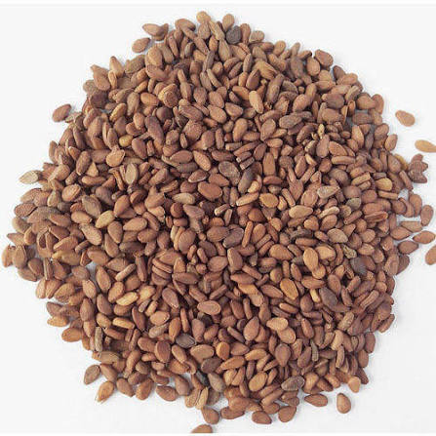

We offer sesame seeds which are highly clean and good quality seeds for your sesame products. The seeds are premium products that available to exporters and many local companies, features including high grain, high oil content,and dirt free. The power of the sesame seed dates back to thousands of years ago when it was used by the Egyptians as a medicine and when the women of ancient Babylon mixed honey with sesame seeds to prolong youth and beauty. While we can’t completely guarantee sesame will keep you looking younger, it can actually be really good for your skin. But mind you, healthy skin is just one of the numerous benefits of adding sesame seeds to your diet! We supply a various varieties of sesame seeds including white, red and black Do you need high quality Sesame seeds to be supplied? Contact us below!

Benefits of adding sesame seeds to your diet Excellent for your skin and hair: You should still remember my little story of Babylon when sesame seeds were being used to help prolong beauty. This is actually because sesame has been scientifically proven to give significant improvement to the skin and hair. In fact, many skin care and hair care products contain sesame seed extracts. The seeds carry many complex B vitamins which are important for many parts of your body, including your hair, skin, and eyes. These B vitamins include thiamin, niacin, folic acid, pyridoxine, and riboflavin. Packed with wonderful minerals: The sesame seed is rich in essential minerals like copper, magnesium, and calcium. It’s vital that your body gets a regular dose of these minerals as they carry many health benefits. Copper is good for sufferers of rheumatoid arthritis while magnesium is useful for helping those people with respiratory problems. Good source of protein and fibers: They may be tiny in stature but sesames are big when it comes to providing your body with protein and fiber. This protein will help in the maintenance and development of muscles, while the fiber from sesame seeds helps support a healthy digestive system. Allows development of strong bones: Sesame is a great source of both calcium and zinc, and both these minerals play a key role in helping to maintain strong, healthy bones. Eating sesame on a regular basis can help prevent osteoporosis, making sesame seeds a popular part of the diet of older individuals.

THREE TYPES OF SESAME SEEDS ARE SHOWN BELOW: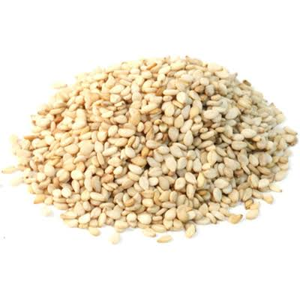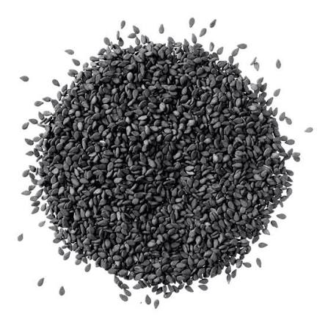

TO ORDER CONTACT INFORMATION:

Head Office-Suite 53, 70d Allen Avenue, Shadatu Plaza, Lagos, Nigeria
Warehouse: Dawannu International grain Market, Along Kastina Road, Kano, Nigeria.

Tel: 08060891851 E-mail: omjadnigltd@gmail.com

