SOYA BEAN
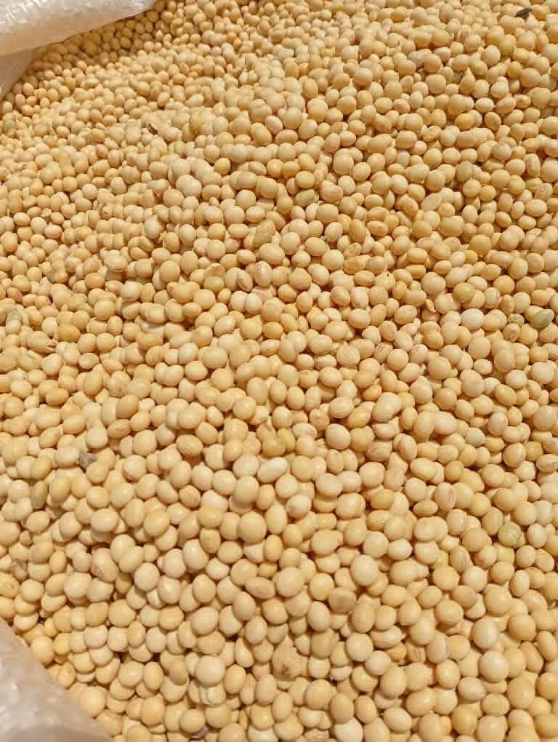

Soybeans (Glycine max) are grown globally as a major source of plant-based protein and oil, used in foods like soy milk, tofu, and oil, and as high-protein animal feed, and offering various health benefits like cholesterol reduction. They are very rich in protein, fiber, vitamins, and minerals.

Key Characteristics Type: Legume, part of the pea family. Composition: High in protein (around 38%), oil (around 18%), carbohydrates, fiber, vitamins, and minerals. Uses: Food (whole, soy milk, tofu, oil), animal feed (soybean meal), industrial products, and a rotational crop.

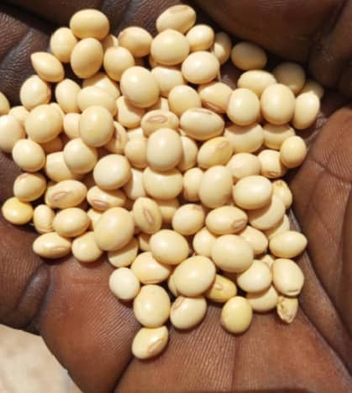

Benefits: Inexpensive, high-quality protein source; may lower cholesterol; improves soil fertility (nitrogen fixation). Global Reach: Grown worldwide, with major producers including the US, Africa Brazil, and Argentina. Health Aspects A serving of soy products can help lower bad cholesterol (LDL) and triglycerides, notes Better Health Channel. May help reduce risks of cardiovascular disease, stroke, and some cancers. Whole soy foods often offer greater benefits than heavily processed versions, say Healthline and the Better Health Channel.

TO ORDER CONTACT INFORMATION:

Head Office-Suite 53, 70d Allen Avenue, Shadatu Plaza, Lagos, Nigeria
Warehouse: Dawannu International grain Market, Along Kastina Road, Kano, Nigeria.

Tel: 08060891851 E-mail: omjadnigltd@gmail.com

